
DHARMSINH DESAI UNIVERSITY, NADIAD
FACULTY OF MANAGEMENT AND INFORMATION SCIENCE
B.C.A. SEMESTER VI
SUBJECT: (25BCA601)SYSTEM DEVELOPMENT PROJECT

Student Name | Himanshu D Ladha
Roll No | BCA045
Student ID | 23BCUOS055

Project Definition: RestoFlow – A full-stack Restaurant Management Platform.

Company Timing: 11:00 AM to 6:00 PM

Week | Date | Day | Name of the Topic | Signature
Fifth Week | 29-12-2025 | Monday | Dashboard improvements and Menu QR code functionality
Fifth Week | 30-12-2025 | Tuesday | Implementation of Payment Handling, Order Cancellation, and Admin Role Enhancements
Fifth Week | 31-12-2025 | Wednesday | Customer QR Ordering Flow with Payment and Advanced Filtering
Fifth Week | 01-01-2026 | Thursday | Home Page Enhancement & Restaurant Review System Implementation
Fifth Week | 02-01-2026 | Friday | Kitchen Dashboard – restaurant admin side

External Guide Name: Somil Sir Internal Guide Name: Prof. Rupal Patel
Signature Signature

29-12-2025
- In Dashboard, added the temporarily view things like Today’s order, Pending Order, Total Meals, Total Tables.
- Added the features of QR code in the menus of the restaurant admin side as per the table wise. It will not work now on the mobile because of localhost connection.
- They can see the QR code and also copy the url also in this …
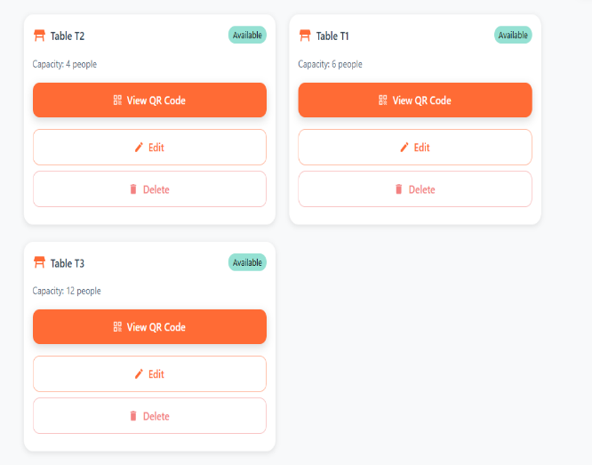
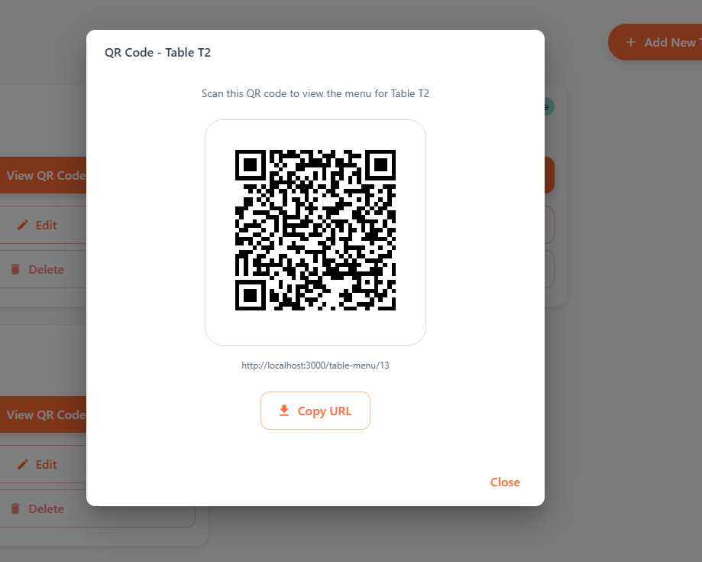
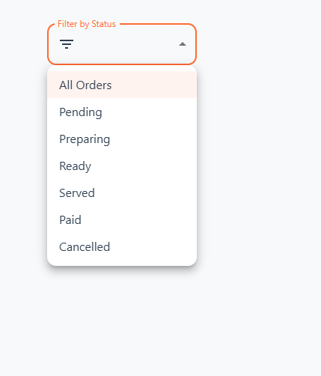
- Added the search bar in the program, So they can search manually what they want. For every different fields, different search filter are there.
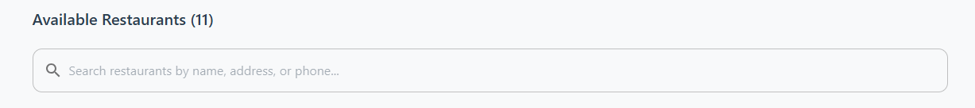

- Added the Filter by status option to filter out the things.
30-12-2025
- Added the functionality of payment method in the paynow click event. Now just set the status of that particular payment only.
- And the cancel order button also from the customer side.
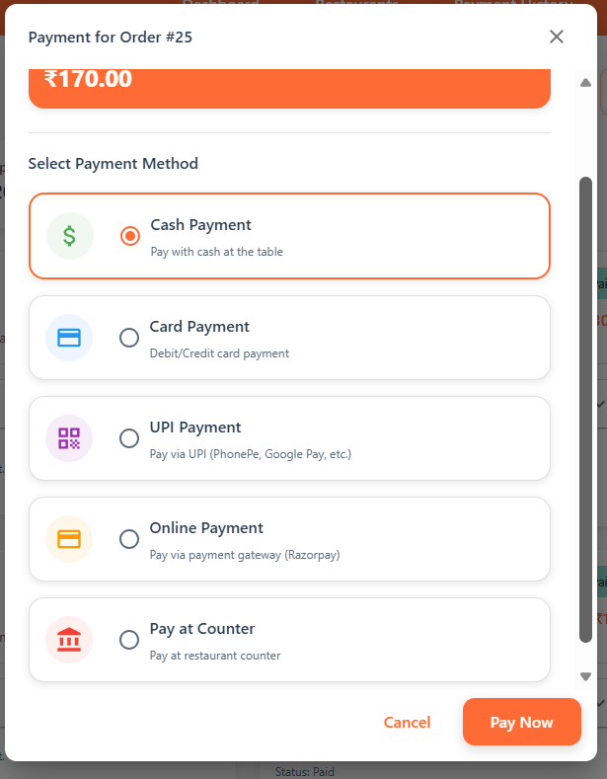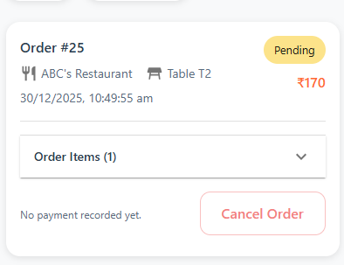
- Added the functionality from the admin side to update and delete the restaurant admin details. And if user is registered then add the feature to add new restaurant from that edit button feature.
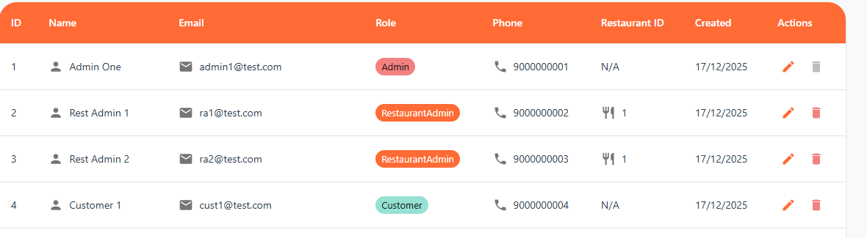
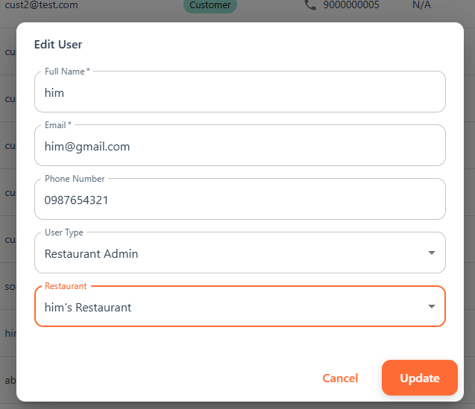
31-12-2025
- Implemented table-wise QR codes for the customer side. When a customer scans the QR code, the menu opens for that specific table. Orders can be placed only after logging in.
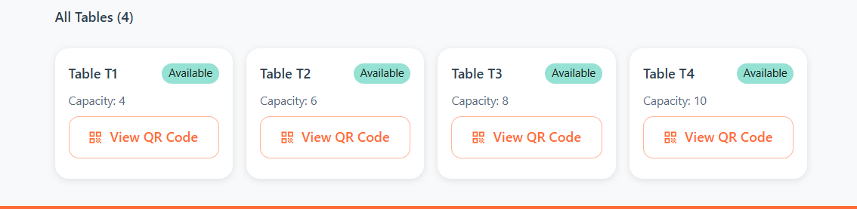
- Added payment options during QR-based ordering, including Pay at Counter, Online Payment, etc. Once payment is selected, the order is submitted to the kitchen/admin.
- Integrated a search bar to allow users to quickly find items.
- Implemented category-wise menu sorting, along with additional sorting options such as price and name.
- Added an advanced price filter allowing users to filter items based on a selected minimum to maximum price range.
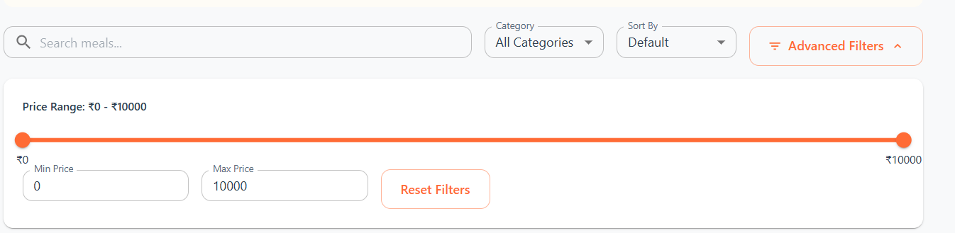
01-01-2026
- Updated the Home page(Landing page) with new and improved design to provide a better user experience and faster loading for both customer and restaurant admin.
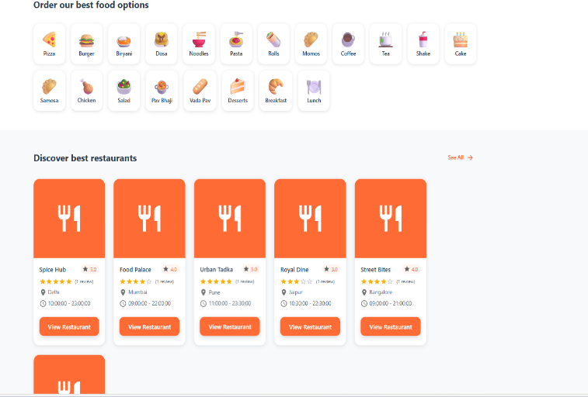
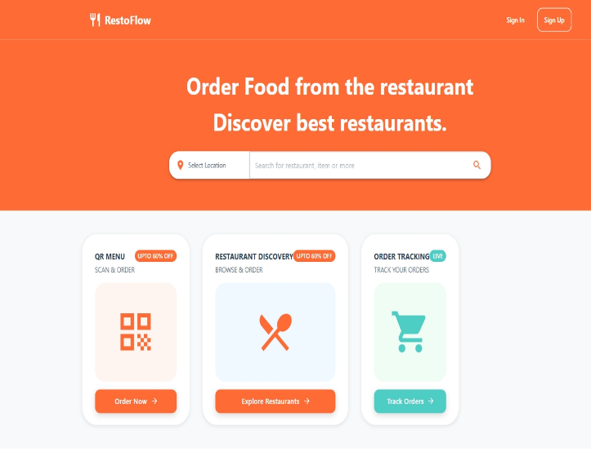
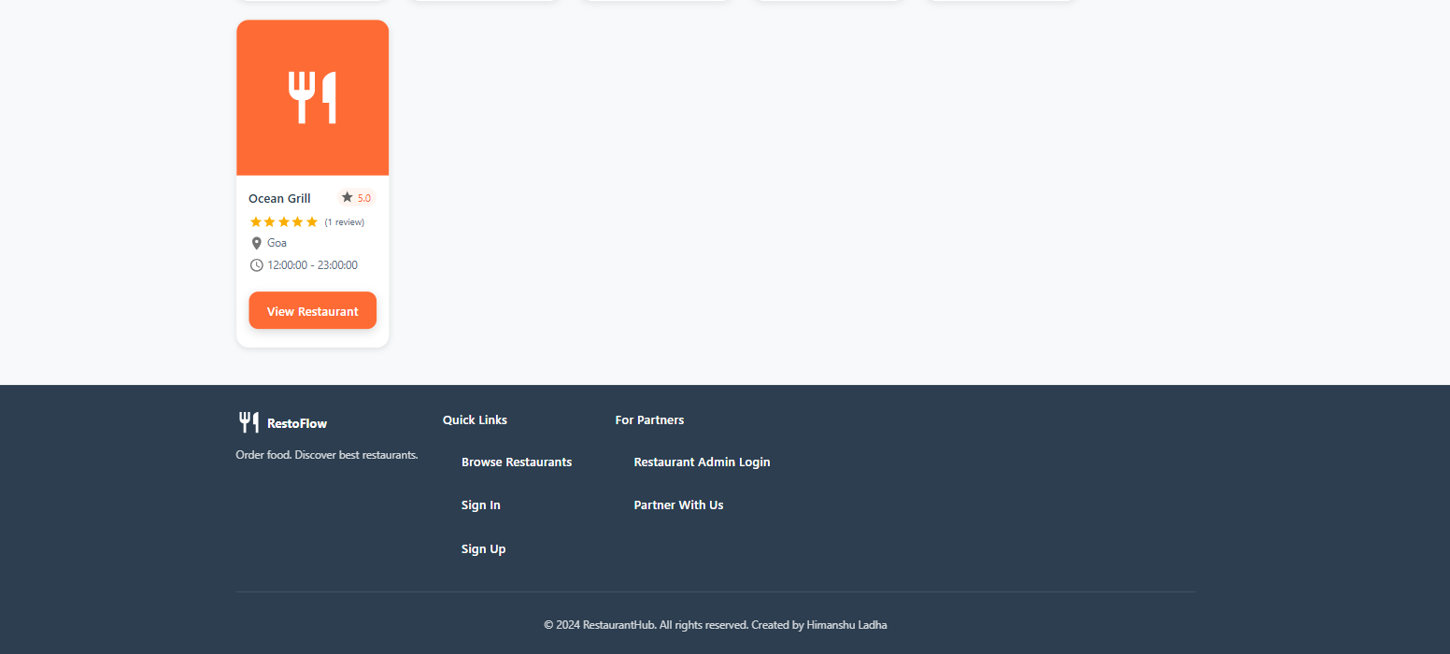
- Implemented a Restaurant Review System where customers can submit a review for a restaurant. Each customer is allowed to submit only one review per restaurant, with the option to edit or update their review later.
- Enabled the Restaurant Admin to view and analyse all customer reviews through a Reviews Analytics section, providing insights into customer feedback and ratings.

02-01-2026
- First created the kitchen dashboard, instead of routing, I have putted the onclick event from the main dashboard only.
- Means in today’s order card on clicking it can see the order of today. Same for all the cards.
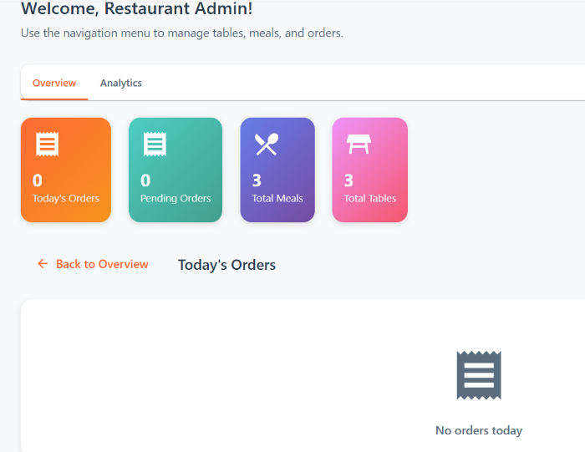
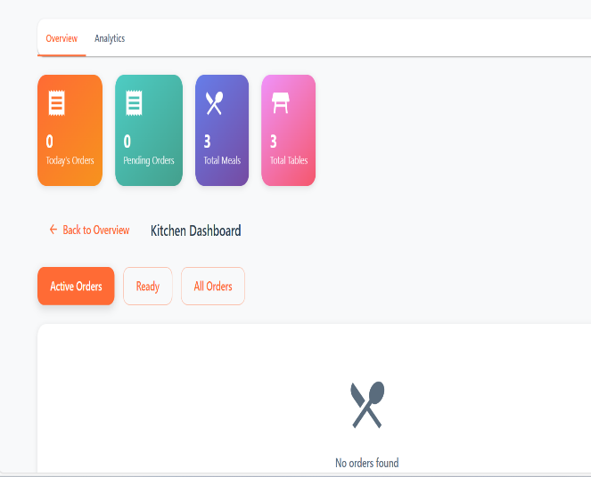
- And in the Analytics section: They can check the Total orders, Total revenue, Todays revenue etc things by the particular days.
- Check the most selling items list wise.
- Payments method : Cash or online payment details.
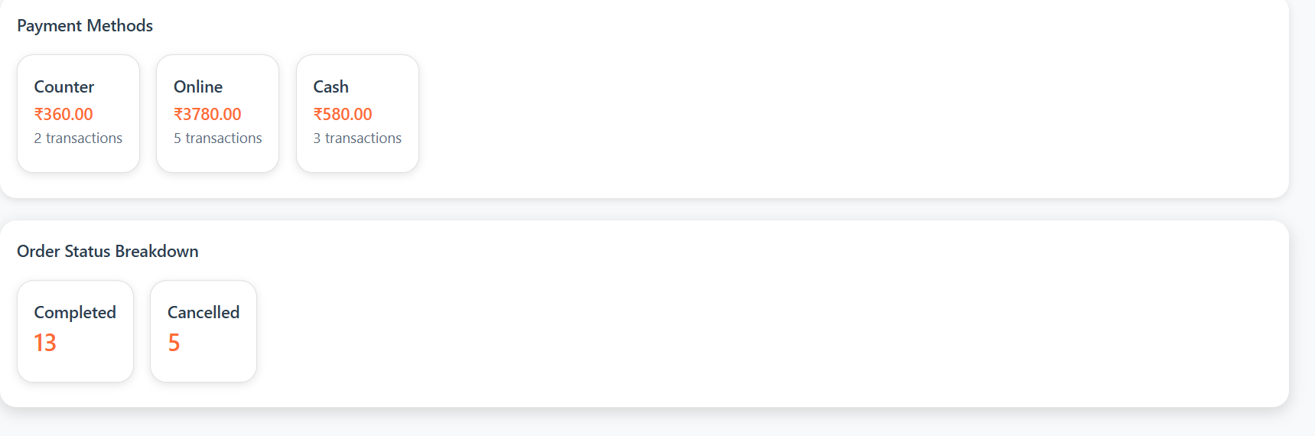
- Order status breakdown.
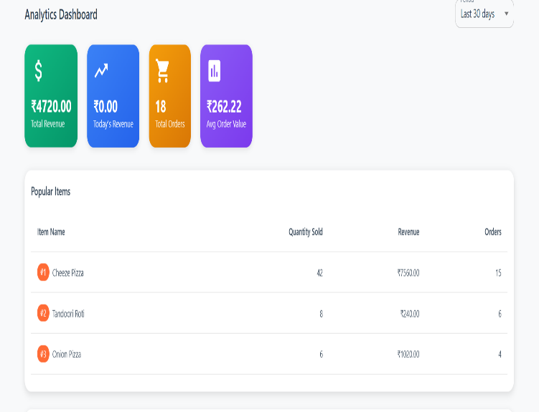

*Names can be changed

